Fast adaptive CS based image compression
Iordan Iulian Bogdan

Abstract
We present a compression scheme based on compressive sensing and a GPU reconstruction pipeline for it, with real-time reconstruction as the long-term goal. The image is down sampled 2×, segmented by k-means, and a key-selected random subset of the remaining pixels is kept, at a different rate per segment. Reconstruction solves each tile at the reduced resolution by reweighted-L1 FISTA, upscales it 2× with AVIR, and refines the luma with a measurement-consistent alternating direction method of multipliers (ADMM). Batching all tiles on a consumer GPU (HIP) reduces reconstruction of a 12 MP image from 42.4 s to 7.0 s with identical PSNR (32.66 dB). The stored container is 4.0× smaller than lossless PNG with 8-bit values, and 6.3× smaller with 5-bit values at a cost of 0.13 dB.

1 Introduction
Compressive sensing (CS) recovers a signal from far fewer measurements than samples by exploiting sparsity in a transform basis [1]. We study the segmented path of our codec. The image is first shrunk 2× per axis, leaving a quarter of the pixels. The shrunk image is partitioned into regions of similar content by k-means clustering, and each region gets its own sampling rate: flat regions keep few pixels and detailed regions keep more. Only the kept pixel values are stored; everything else is reconstructed, and the result is enlarged 2× back to full size. A side effect of this sampling method is that the kept values can be stored as plain values, while their positions are not stored at all and are regenerated from a key; without the key the values cannot be put back in the right places, so the same format also has potential for encryption.
Reconstruction is an inverse problem that costs minutes per 12 MP image on a CPU. One of the goals of this work is to make it run in real time eventually, so that a compressed image can be viewed as fast as it is decoded; the GPU results here are a first step (7.0 s for 12 MP). Our contributions are: (i) a GPU implementation of every heavy stage, with the measured effect of each optimization; (ii) analysis and visual comparison of each approach regarding reconstruction quality.

2 Method
Figure 1 shows the pipeline. Reconstruction works per tile: the shrunk image is cut into overlapping tiles of about 48×56 px, each using only the kept samples that fall inside it. Figure 2 shows an example segmentation and sampling mask for the test photograph.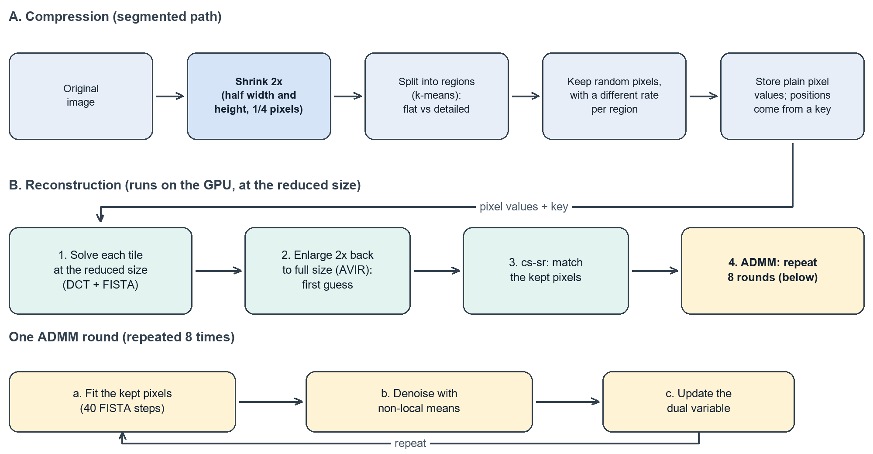
Figure 1. The segmented path: (A) the image is shrunk 2×, split into regions and sampled with a different rate per region; (B) reconstruction solves at the reduced size, enlarges 2× back to full size, and refines with repeated ADMM rounds.
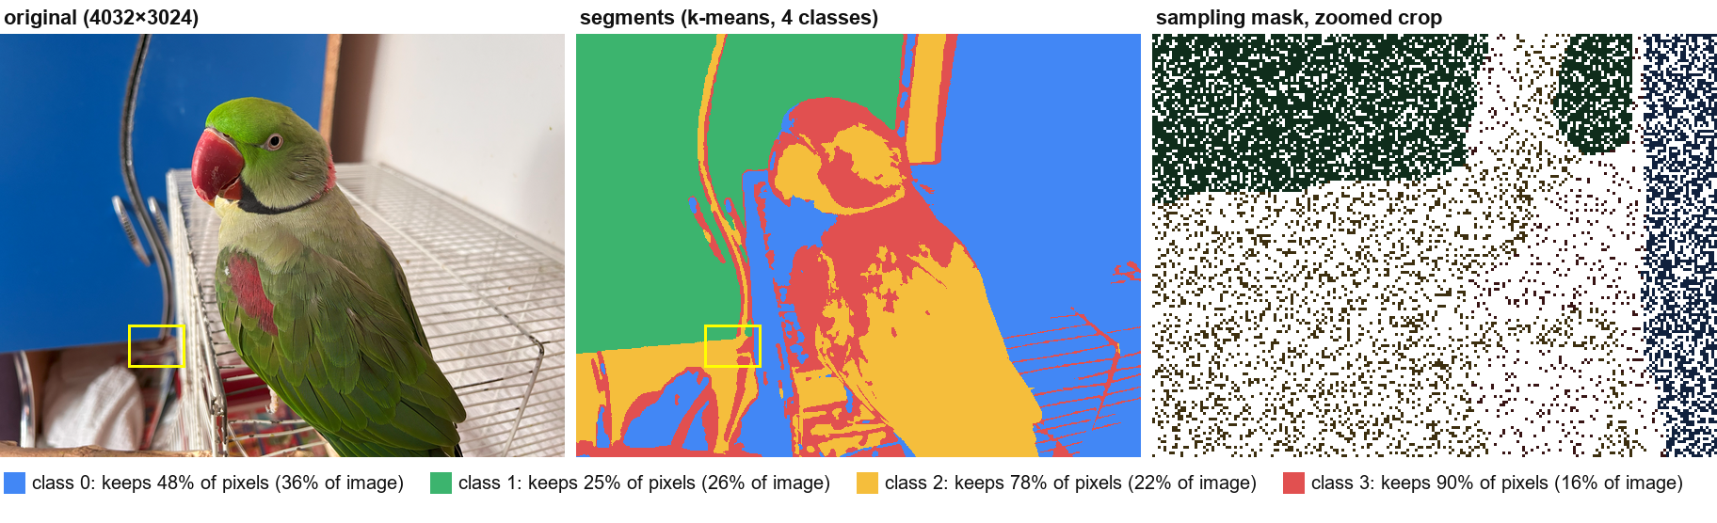
Figure 2. Segmented sampling on the test photograph. Left: the original. Middle: the four k-means segments of the 2×-shrunk image (the container's actual label map). Right: a zoomed crop (yellow box) of a sampling mask; kept pixels are white and dropped pixels are dark, tinted by class. The per-class rates are those chosen automatically by the encoder (0.53, 0.28, 0.87 and 1.00, multiplied by the ratio 0.9), which keep about 55% of the shrunk pixels overall; the individual positions drawn are an illustrative random draw, since the real ones are derived from the key. Flat regions (class 1) keep few pixels, detailed regions (classes 2 and 3) keep most.
Low-resolution solve. For each tile we look for the DCT coefficient vector with the smallest weighted L1 norm whose inverse transform agrees with the kept samples. The orthonormal 2-D DCT makes the sensing matrix a row-selection of an orthogonal matrix, and the problem is solved by reweighted-L1 FISTA [2], which alternates a gradient step on the data term, soft-thresholding with per-coefficient weights, and Nesterov momentum.
Enlargement with AVIR. AVIR is Aleksey Vaneev's image resizing library, a high-quality windowed-sinc (Lanczos-type) interpolator. It is a purely linear resampler: it knows nothing about which pixels were actually measured. Its output x₀ is therefore a good but blurry initial estimate, which the next stage corrects.
What ADMM does. ADMM, the alternating direction method of multipliers [3], solves a hard problem by splitting it into two easier ones and alternating between them. Here the two problems are data fidelity (find an image that agrees with the kept samples) and naturalness (denoise the image with non-local means, which stands in for the knowledge that natural images are locally self-similar, the plug-and-play idea [4]). A third quantity, the scaled dual variable, accumulates the disagreement between the two estimates and feeds it back into the next round, so that after enough rounds both estimates converge to one image that satisfies both. The penalty ρ sets how strongly each round is pulled towards the current denoised estimate: a large ρ keeps the result close to the AVIR starting image, while a small ρ lets the measured samples dominate. This is why ρ turns out to be the main quality parameter (Section 4).
cs-sr and ADMM. The luma plane x of x₀ is refined against the measurements. A measured value is modelled as the mean of a 2×2 block of the high-resolution image, observed only at the sampled reduced-resolution cells. Writing the data term as the squared residual of this 2×2 averaging on the sampled cells, one ADMM round [3, 4] (a) minimizes the data term plus a quadratic anchor of weight ρ and an L1 term around the current denoised estimate, in the DCT domain, with 40 FISTA steps; (b) replaces the denoised estimate by a non-local-means [5] filtering of the result plus the scaled dual variable; and (c) updates the dual variable by the difference between the two. We run 8 rounds starting from x₀, with ρ = 0.1 by default. The denoiser runs on 8-bit luma with strength h = 1.6σ̂, where σ̂ is an Immerkaer noise estimate of the tile, clamped to [3, 30]. Chroma is left at its AVIR value.

3 GPU implementation
All states of a stage stay on the device for the whole loop, and tiles of different sizes share one launch (one thread-block row per tile, per-tile DCT tables). Items 1–3 below account for the speed-up in Table 1.
- Batched low-resolution solve and flat tile loop. The CPU solver warm-starts each tile from its neighbours and therefore needs a wavefront of diagonals with a barrier after each. Dropping the warm start makes the tiles independent: 4096 tiles × 3 channels are solved in 1.3 s on a 64×64 grid instead of 29 CPU-thread-seconds, and the wavefront is replaced by one flat parallel loop in which every worker takes the next tile and submits its ADMM work to a batching broker.
- Tiled DCT as batched GEMM. The dense per-tile DCTs run as an LDS-tiled GEMM (32×32 blocks, 4×4 register tiles) whose epilogues fuse the 2×2 residual and the soft-threshold/momentum step, giving 4 kernels per FISTA step instead of 7. Issuing all global loads of a K-chunk together was essential: the first version was slower at small batches.
- GPU noise filter that matches OpenCV. The denoising step uses non-local means, a filter that cleans a pixel by averaging it with other pixels whose surrounding 7×7 patch looks similar. We rewrote OpenCV’s version of this filter for the GPU and copied its arithmetic exactly: patch differences are computed with whole numbers, the averaging weights use fixed-point (integer) maths instead of floating point, and pixels at the image edge are handled by mirroring the image. The result matches OpenCV almost exactly. In a test of 139,920 pixels, only 2 differed, and each by a single grey level out of 255.

4 Experiments and results
Setup: Ryzen 9 7900 CPU, Radeon RX 7900 XT GPU, a 4032×3024 photograph (IMG_3690, 3969 tiles), segmented path (shrunk 2×, four segments, sampling ratio 0.9), automatic settings. Quality is PSNR against the full-size original; edge PSNR uses the 10% of pixels with the largest gradient.

Table 1. Reconstruction time.
Step | Time | Speed-up
CPU only | 42.4 s | 1.0×
+ GPU ADMM, naive DCT kernels (CPU low-res solve, wavefront) | 19.7 s | 2.2×
+ tiled DCT GEMM kernels | 12.5 s | 3.4×
+ GPU low-res solve | 12.7 s | 3.3×
+ flat tile loop | 7.0 s | 6.1×
The reconstruction quality is the same in every row (32.66 dB). Moving the low-resolution solve to the GPU alone does not help (12.7 vs 12.5 s) but is what makes the flat loop possible. Without the warm start the GPU and CPU outputs differ slightly; the CPU path is unchanged.
Table 2. Effect of each reconstruction stage (GPU, automatic settings).
Stage | PSNR (dB) | Edge PSNR (dB) | Time (s)
AVIR upscaling only | 31.21 | 23.65 | 2.9
+ cs-sr | 32.05 | 24.31 | 5.5
+ ADMM | 32.66 | 25.07 | 7.0
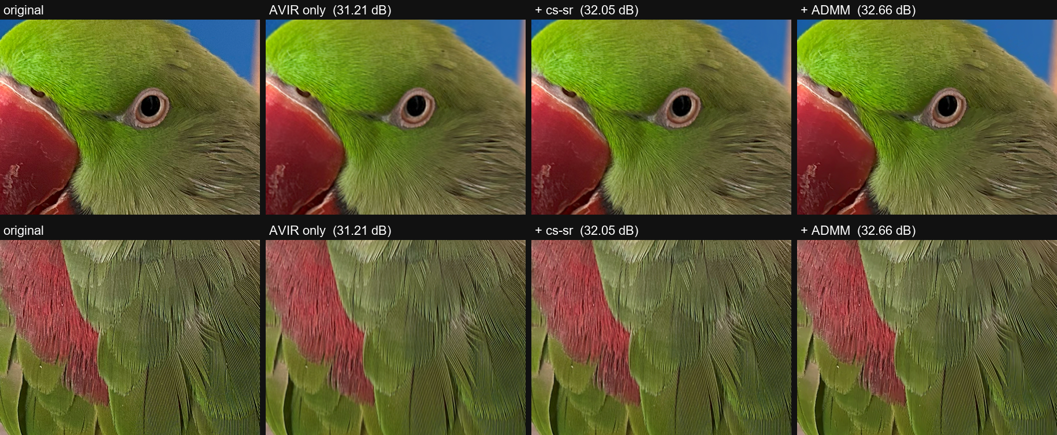
Figure 3. Two 800×600 crops of the 4032×3024 test photograph (head and wing feathers): original, AVIR upscaling only, after cs-sr, and after ADMM. PSNR is for the whole image. At this zoom the stages differ subtly: each step recovers a little more fine feather detail, and the gains are mostly visible as the measured PSNR increase.
Anchor strength. Over six photographs and two sampling ratios, lowering ρ from 0.1 to 0.01 improves PSNR by 0.25 dB on average at ratio 0.9 (+0.10 dB at 0.5), from −0.08 to +0.69 dB per image; strong anchors are harmful (ρ = 3 gives 27.7 dB, below plain AVIR). A schedule that raises ρ and lowers the NLM strength over the rounds adds a little more (+0.32 dB on average at ratio 0.9, up to +0.92 dB on one image), whereas rescaling the dual variable when ρ changes hurts (−0.12 dB). Seams. Within 8 px of segment boundaries (12% of the image) every stage loses about 1.5 dB relative to the interior, and we saw no ringing.
Compression rate. Table 3 gives the size of the stored container for the test photograph (12.2 MP, 20.3 MB as lossless PNG) when the kept sample values are quantized to fewer bits per value (the encoder's sample-bits option; the header and segment data are unchanged). Every row was encoded and reconstructed with the full pipeline, and PSNR is measured against the original. The container is a PNG holding the plain kept values.
Format | Size | Bits per pixel | Smaller than PNG | PSNR (dB)
PNG (lossless original) | 20.26 MB | 13.3 | 1.0× | exact
Container, 8 bits per value | 5.11 MB | 3.35 | 4.0× | 32.66
Container, 7 bits per value | 4.50 MB | 2.95 | 4.5× | 32.63
Container, 6 bits per value | 3.86 MB | 2.53 | 5.3× | 32.63
Container, 5 bits per value | 3.22 MB | 2.12 | 6.3× | 32.53
Container, 4 bits per value | 2.48 MB | 1.62 | 8.2× | 31.71
YCC 4:2:0 container, 8 bits per value | 2.45 MB | 1.61 | 8.3× | 32.52
Table 3. Container size and reconstruction quality versus bits per kept value (test photograph, ratio 0.9, four segments; bits per pixel refer to the 12.2 MP original).
At 8 bits per value the container is 4.0× smaller than lossless PNG. Quantizing the kept values is almost free down to 6 bits (−0.03 dB) and costs 0.13 dB at 5 bits, where the container is 6.3× smaller than PNG; at 4 bits the loss grows to 0.95 dB (8.2× smaller). Container size scales almost exactly with the number of bits per value, because the packed values do not compress further under PNG. Further gains would need entropy coding of the quantized values and an efficient coding of the segment map; the sampling ratio is a further lever that is not explored here. A YCC 4:2:0 container (luma at full resolution, chroma on a half-resolution grid) with the same ratio and segmentation is 2.45 MB, 8.3× smaller than PNG, and reconstructs at 32.52 dB: about half the size of the BGR container for 0.14 dB less. Figure 4 shows both containers.
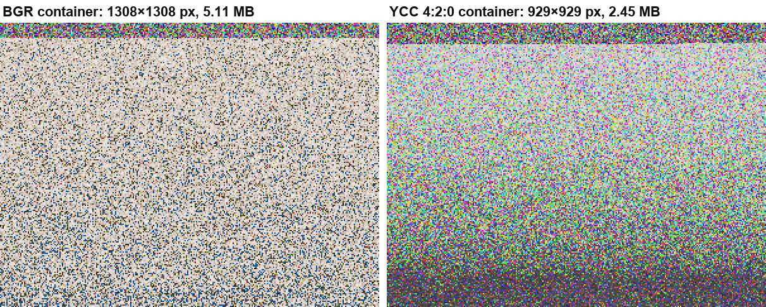
Figure 4. Stored containers for the test photograph (ratio 0.9, four segments), top-left 300×225 pixels at 2× zoom. The top rows hold the encrypted header and segment-map data; below them the kept values appear in a key-shuffled order, so no image structure is visible. Left: BGR container. Right: YCC 4:2:0 container, which stores the luma, Cr and Cb samples one after another; they are displayed here as if they were RGB, so the colours have no meaning.
Edge-weighted sampling (preliminary). The segment rates give every pixel of a segment the same sampling probability. We tested whether sampling more densely on edge-rich areas inside each segment helps. On the shrunk grid, the 16×16-pixel blocks of each segment were ranked by mean Sobel gradient and the top 50% per segment were marked as edge blocks. The label map then carries 2K classes (segment × edge flag), so the unmodified decoder redraws the positions from the shipped map and rates, exactly as for any segment mask. Edge blocks keep 1.5× their segment's rate (capped at 1) and the other blocks are lowered so that each segment keeps the same number of samples as in the automatic baseline, which matches the total sample count. The larger label map is included in the container sizes of Table 4. The settings (block size, top fraction, boost) were chosen on IMG_3690 from ten configurations, whose PSNR ranged from 32.91 to 33.18 dB against 32.68 dB for a control that splits the classes without changing the densities; the other three photographs use these settings unchanged. All runs use sampling ratio 0.9 and four segments.
Table 4. Automatic segment sampling versus edge-weighted sampling at matched sample counts (ratio 0.9, four segments). Settings tuned on IMG_3690 only.
Photo | Samples (M) | Automatic: size / PSNR | Edge-weighted: size / PSNR | Gain (dB)
IMG_3690 (tuned) | 1.70 | 5.11 MB / 32.66 dB | 5.14 MB / 33.18 dB | +0.52
IMG_0007 | 2.56 | 7.61 MB / 37.79 dB | 7.66 MB / 38.02 dB | +0.23
IMG_1297 | 2.30 | 7.18 MB / 22.49 dB | 7.18 MB / 23.00 dB | +0.52
IMG_9321 | 1.08 | 3.12 MB / 32.67 dB | 3.18 MB / 36.03 dB | +3.36
The gain is positive on all four photographs: +0.23 to +0.52 dB on three, and +3.36 dB on IMG_9321, an outlier that we have not examined. The container grows by 0.03% to 2% because of the larger label map. This is a preliminary result with clear limits: four photographs from the same phone, one sampling ratio, one segmentation, and settings tuned on a single image. In addition, the decoder scales its regularization by each class's rate, so part of the gain may come from that rather than from the sampling itself; we did not separate the two.
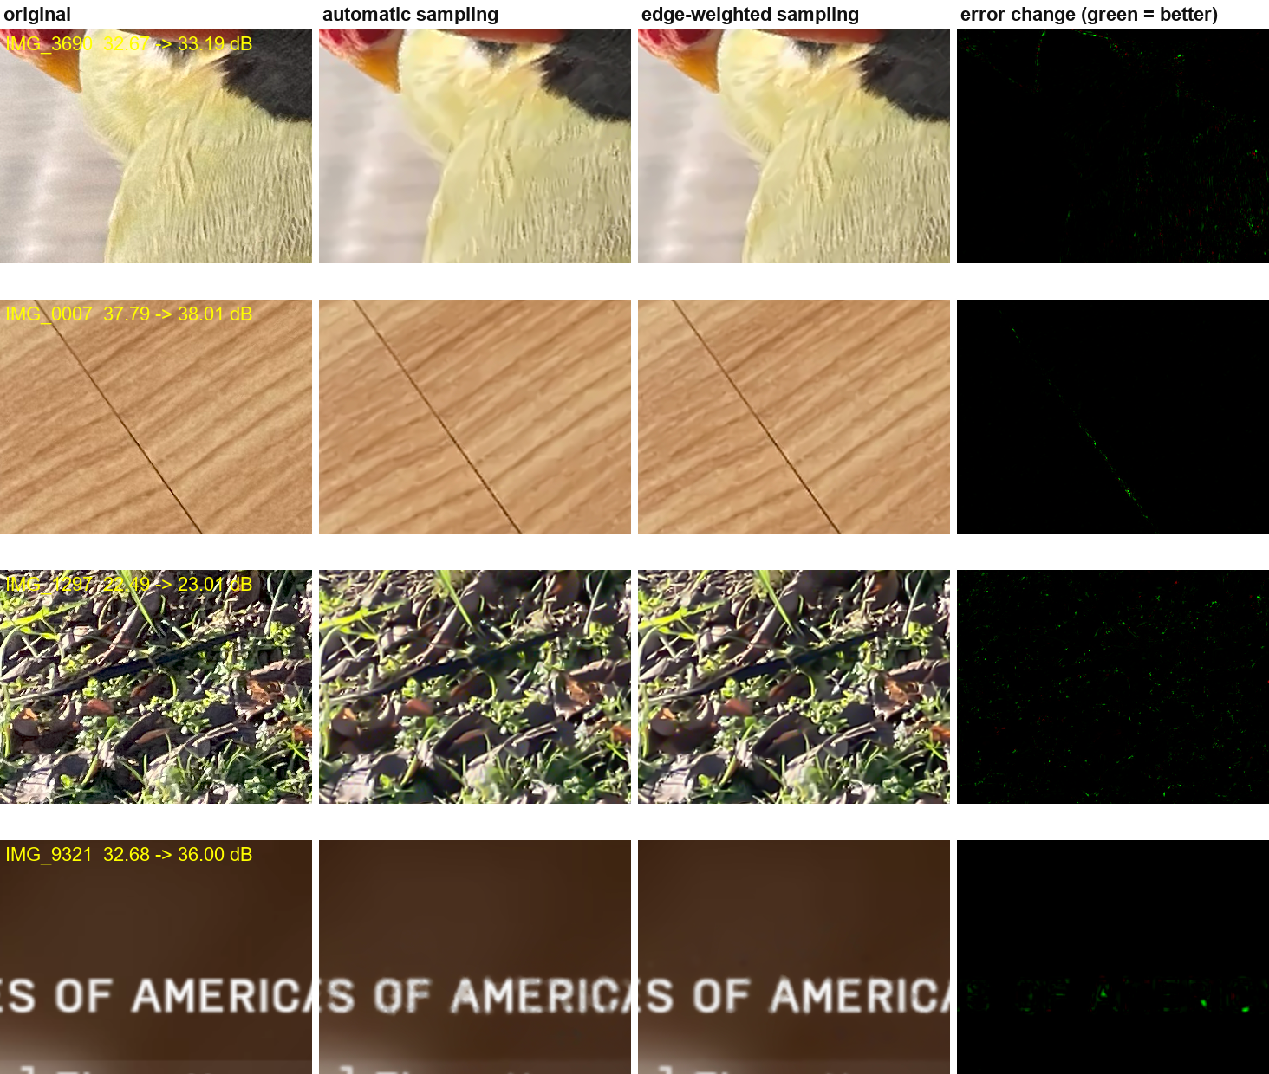
Figure 5. Automatic versus edge-weighted sampling on the four photographs (ratio 0.9, four segments). Each row is a 360×270-pixel crop at full resolution, chosen automatically as the window with the largest relative error reduction among regions with above-average error, so the crops show favourable cases rather than typical ones. Columns: the original; the reconstruction with automatic segment sampling; the reconstruction with edge-weighted sampling; and the error change, shown in green where the edge-weighted reconstruction has the lower squared error and in red where it has the higher one (scaled separately for each row). The PSNR in each row is for the whole image, from a re-run that agrees with Table 4 to within 0.02 dB. The largest effect is on the lettering in IMG_9321, which is visibly sharper; on the other photographs the difference is subtle.

5 Discussion and limitations
The result that ρ matters more than the quality of the starting estimate follows from the model: a weak anchor lets the measured samples overrule x₀, so AVIR's blur is corrected where samples exist, while a strong anchor keeps the solution close to x₀ and cancels the benefit. The downscale-then-upscale pipeline is also not simply worse than full-resolution coding: at about 1.2 M sample slots both reach about 31 dB, and full resolution wins beyond that (35.4 dB at 2.3 M slots), because the 2× reduction makes the same samples three times denser on the grid being solved.
Limitations. The timing study uses one photograph and one container type (BGR, four segments, no 4:2:0 chroma). The ρ sweep covers six photographs, two of which (DIV2K) behave differently and have unusually low PSNR that we did not investigate. We did not compare CPU and GPU versions of the ρ schedule. No hardware GPU counters were available on this platform, so statements about kernel efficiency rest on event timings. Chroma is not refined.

6 Conclusion and future work
A batched GPU pipeline reconstructs a 12 MP image in 7.0 s instead of 42.4 s without changing the CPU path, and shows that the ADMM anchor strength is the main quality lever. Real time is still a large factor away, so the next steps are aimed at it (proposals, not yet measured): fewer ADMM rounds and FISTA steps with a calibrated ρ, fusing the NLM and DCT kernels, and extending the GPU path to 4:2:0 containers and full-resolution mode. A lightweight machine-learning enhancement pass, trained specifically on images compressed with this method, is also proposed: it would learn to correct the codec's own characteristic reconstruction errors (for example the seam losses and the blur left in textured regions). For the compression side, the next steps are entropy coding the quantized values, an efficient coding of the segment map, and tuning the sampling ratio. A preliminary experiment (Table 4) also suggests that sampling more densely on edge blocks inside each segment improves PSNR at the same sample count.

Acknowledgments
Use of AI assistance. Various aspects of the implementation, benchmarks and the drafting and editing of this paper were done with the assistance of AI.

References
- E. J. Candès, J. Romberg, T. Tao, "Robust uncertainty principles: exact signal reconstruction from highly incomplete frequency information," IEEE Trans. Inf. Theory 52(2), 2006.
- A. Beck, M. Teboulle, "A fast iterative shrinkage-thresholding algorithm for linear inverse problems," SIAM J. Imaging Sci. 2(1), 2009.
- S. Boyd et al., "Distributed optimization and statistical learning via the alternating direction method of multipliers," Found. Trends Mach. Learn. 3(1), 2011.
- S. V. Venkatakrishnan, C. A. Bouman, B. Wohlberg, "Plug-and-play priors for model based reconstruction," IEEE GlobalSIP, 2013.
- A. Buades, B. Coll, J.-M. Morel, "A non-local algorithm for image denoising," CVPR, 2005.

